Trading Prediction

**STOCHASTIC MODEL**

## **TRADING STRATEGY:**

* Using technical analysis,the Stochastic Slow Strategy indicator has smoother results and fluctuates more frequently between overbought and oversold signals.
* Identifies and determines primary trends within the market.
* The oscillator analyzes periods of highs and lows in order to track trends and deliver overbought and oversold signals to the trader.
* Combined with the moving average indicators used for technical analysis or trend determination, a trader will be set up for success.
* Moving average is used to filter trends for uptrend stock.
* A buy is initiated when the %K line crosses up through the %D line and the value of the oscillator is below 35 and intercept with uptrend signal .This is a signal for OVERSOLD.
* A sell is initiated when the %K line crosses down through the %D line and the value of the oscillator is above 85 .This is a signal for OVERBOUGHT.
* Entry for a buy signal will continue to trigger(save data) until a sell signal appears.

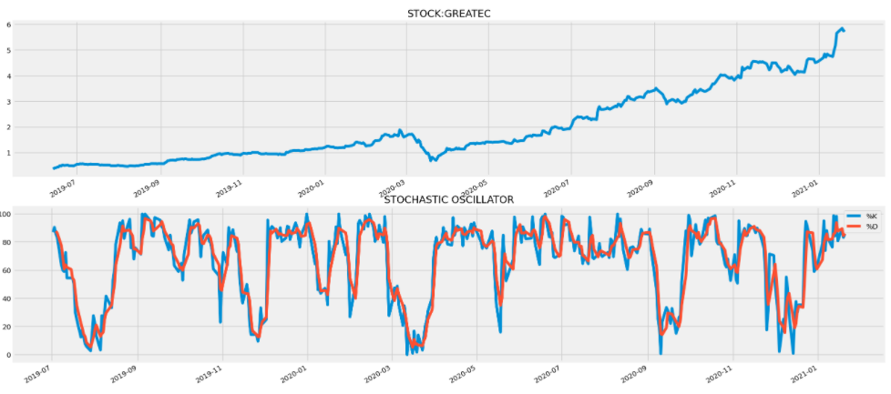.

## **STOCKS USED:**

### STOCKS CRITERIA :

* Strong fundamentals and price tend to move following technical analysis indicators used for trading plans in Stochastic Model.
* Stocks in the same sector (semiconductor):
* GREATEC, UWC, D&O, GENETEC, UNISEM, FRONTKN, ATAIMS, FPI, PENTA, DUFU, VS, SKPRES, MPI, VITROX.

## **BACKTEST - TRADING PLAN:**

* Result 2018
* Total Winning rate 2018 : 53.57%
* Total Winning Percentage 2018 : 16.63%
* Result 2019
* Total Winning rate 2019 : 78.15%
* Total Winning Percentage 2019 : 20.09%
* Result 2020
* Total Winning rate 2020 : 85.38%
* Total Winning Percentage 2020 : 93.44%

## **MACHINE LEARNING PREDICTION (MVP):**

### KEY CONCEPT:

* The main idea of the model is that it will be used to predict the success of each trade. The goal of the model is to predict whether the trade will be successful every time the signal appears according to the trading strategy.
* The inputs to the models will be various features and criterias which are thought to be affecting the success of the trade. For example: Closing Price and Volume of transactions.
* This machine learning model will be a classification model which will only produce 2 outputs. 1 (Thumbs up) or 0 (Thumbs down)
* The algorithm that is used is **XGBoost Classifier**

DATA PREPARATION:

* Data from the backtesting is used as input data.
* The data is filtered to data with buy transactions only.
* Data is scaled into the same scale, so each stock has the same price range to generalize the transaction.
* Initial features are Open, High, Low, Close prices, and Volume of the day.
* Additional features are created to add more dimension to the dataset.

INPUT FEATURES:

* Inputs are chosen from all features created based on their effect on the model accuracy in multiple timeframes.
* Best features are used in the actual model
* Best input features are:
* The Open,Close,High,Low and Volume when buy transactions occur
* Stock name when buy transaction occurs

OUTPUT LABELS:

* Label for class 1 or Thumbs up -
* Likely to reach 7% profit within 1 month period.
* Label for class 0 or Thumbs down -
* Likely not reach 7% within 1 month period.

VALIDATION METHOD (WALK FORWARD):

* Splitting the dataset into multiple frames.
* A timeframe is consists of:
  + - Two years as the training set.
    - The next 1 month is used as the validation set.
    - For example, the first timeframe for the training set is from 01/Jan/2017 - 01/Jan/2019. Then the first timeframe for the test set is from 01/Feb/2019 - 28/Feb/2019.
    - After finishing testing the model from this timeframe, it will test the next timeframes.
    - Then after the validations are done on all timeframes, the accuracy scores for all timeframes are averaged to represent the overall performance of the model.
* Accuracy for test data **0.53**

MODEL DEPLOYMENT:

* Model workflow:
* Using the latest two years time frame before predicted date as the training set of the model.
* Then the model will detect if there are any buy signals for that day, and will predict the result of the buy position. Whether it will win or lose within the holding period for this strategy.
* The result will be saved in MongoDB:
* Trading_Prediction database (Stochastic_Model Collection)
* Each document represents the date of the prediction made.
* Data in collection and document record whether trigger signal or no signal buy produced.

## DEPLOYMENT RESULTS:

### Sample of webpage

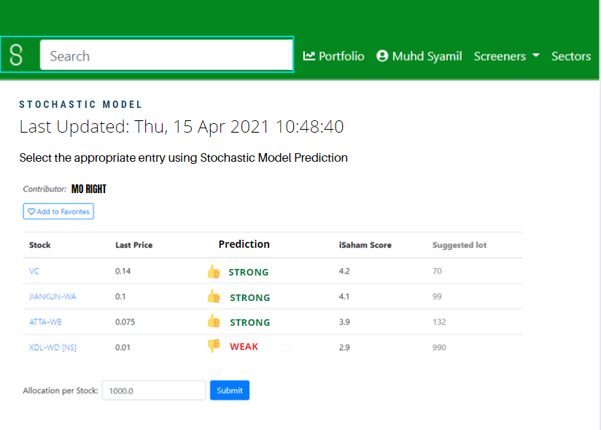

## CASE STUDY

PREDICTION USING STOCHASTIC MODEL FOR 2021

* Used historical data for the test set.
* Training data from first date listing in Initial Public Offering(IPO).
* 28 buy signal prediction recorded from 11 January 2021 to 26 March 2021.
* Total performance for prediction accuracy is **58.62%**

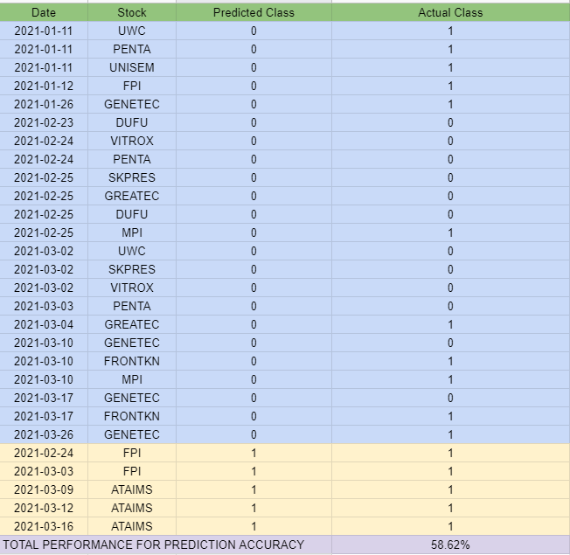

**CASE STUDY 1: ATAIMS**

* Prediction

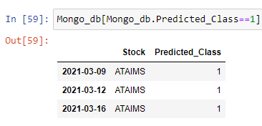

* Actual Data

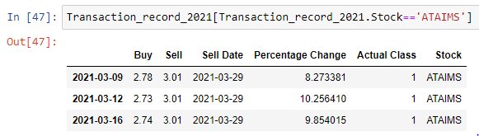

<https://www.tradingview.com/x/APF8uWNd>

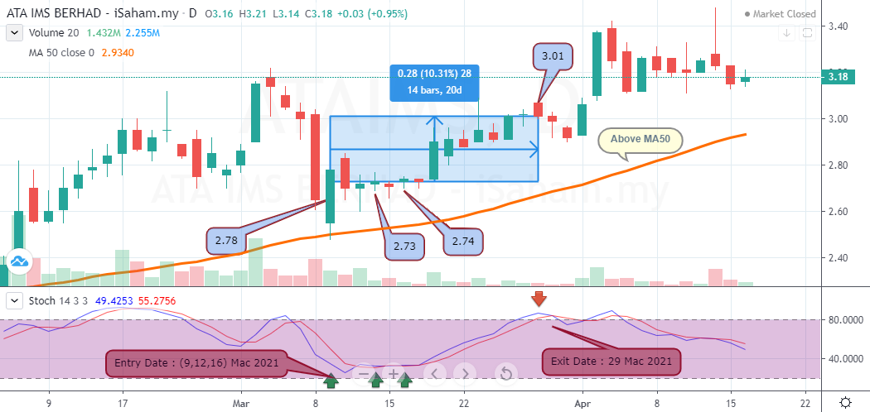

Prediction: **Profit**

Entry date: 09/03/2021, 12/03/2021, 16/03/2021

Exit date: 29/03/2021

Actual price exit: RM 3.01

Actual Result : **Profit**

Profit percentage: 8.27%, 10.26%, 9.85%

**CASE STUDY 2: DUFU**

* Prediction

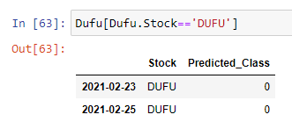

* Actual Data

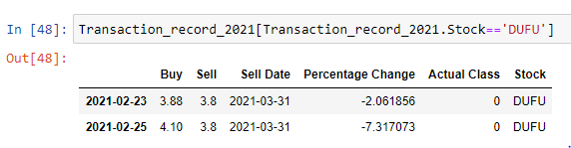

<https://www.tradingview.com/x/gHhTCvYO>

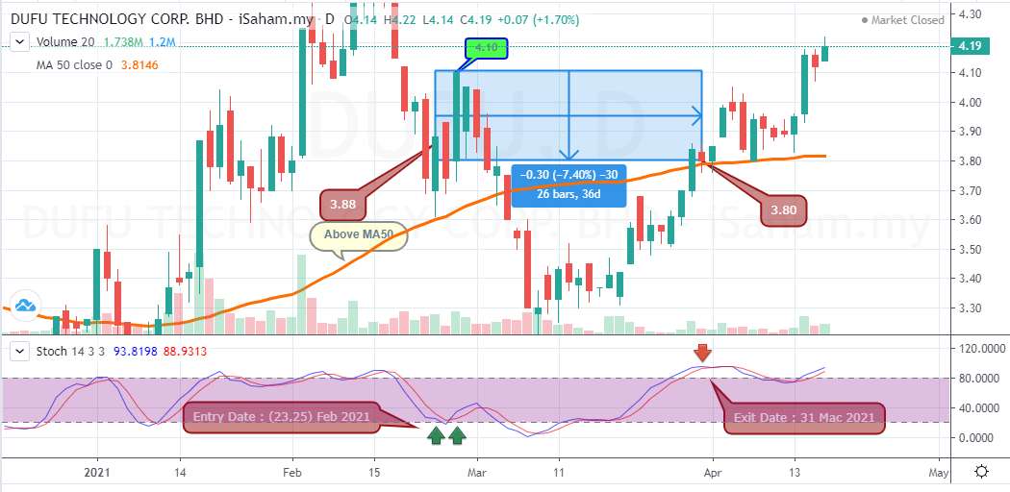

Prediction: **Loss**

Entry date: 23/02/2021, 25/02/2021

Exit date: 31/03/2021

Actual price exit: RM 3.8

Actual Result : **Loss**

Profit percentage: -2.06%, -7.32%

**CASE STUDY 3: MPI**

* Prediction

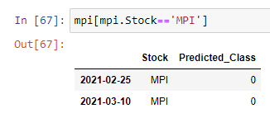

* Actual Data

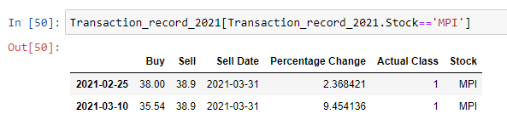

<https://www.tradingview.com/x/8YRusBeO>

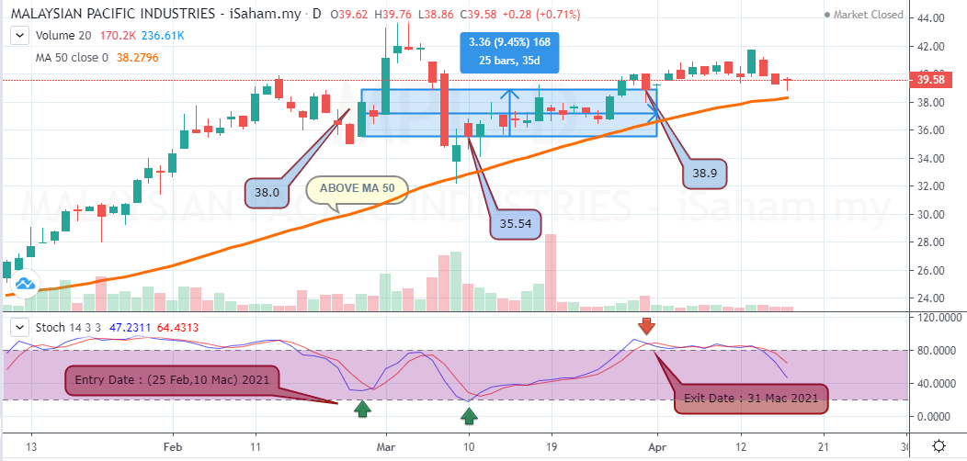

Prediction: **Loss**

Entry date: 25/02/2021, 10/03/2021

Exit date: 31/03/2021

Actual price exit: RM 38.9

Actual Result : **Profit**

Profit percentage: 2.37%, 9.45%

## **LIMITATION AND IMPROVEMENTS**

### LIMITATIONS OF THE CURRENT MODEL:

* Training data
* The current model is trained using default parameters
* Not fully describe stock by stock pattern because of different listing date in BURSA
* Focus on same sector analysis.
* Result for trading strategy winning rate follow economy growth performance
* Model output not reliable with super short term period
* Suitable for short and mid term
* Using trading strategy buy on weakness and rebound
* Buy when oversold
* Sell when overbought

### IMPROVEMENTS:

* Selecting the proper time period for the training set.
* Find the most accurate result when backtesting using a different period of training set.
* Increase accuracy in model performance
* Add new input features to add more dimension to the dataset
* Selecting another machine learning model
  + As an MVP, the machine learning model that was chosen was a basic model. A more sophisticated model could be chosen to improve the model’s performance